
The Printable Household

Notebook

Created By: Nicola Burns

The introduction to this notebook is straightforward. It serves as a centralized repository for all essential tasks. This includes a primary chore chart as well as a financial budget sheet. Upon printing the pages within this notebook, it is advisable to place them in a binder equipped with protective sheet covers, allowing for repeated use.

The following is a list of the tabs included within the notebook:

- Chores categorized by zone (room)
- Budget sheet
- Inventory lists
- Main grocery list
- Birthday and anniversary calendar (annual)
- Monthly calendar

Household Chores
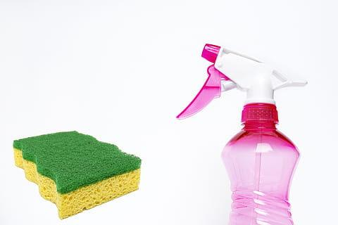

Zone 1: Entrance, Front Porch, and Dining Room
THE ENTRANCE
- Clean cobwebs
- Dust window sills & the front door
- Clean handprints from the switch plate & the walls
- Water Plants
- Dust furniture
- Dust baseboards
- Straighten the coat closet
- Sweep, vacuum, or/& mop the floor
- Add personal touches to the table
THE DINING ROOM
- Clean cobwebs
- Dust window sills
- Clean window
- Clean the doors of the china cabinet, straighten the dishes, & dust
- Clean & straighten the drawer
- Clean off the top of the dining table & polish it
- Water Plants
- Dust the bottoms of chairs
- Dust baseboards
- Move furniture & vacuum underneath
- Add personal touches to the table
THE FRONT PORCH
- Sweep down spider webs
- Sweep off porch furniture
- Sweep porch
- Throw away any dead plants
- Prune back unruly bushes from the entrance
- Repot planters if necessary (in summer)
- Refill bird feeders
- Wipe off tables, banisters, & light fixtures
- Get rid of unwanted items

Zone 2: The Kitchen

THE KITCHEN
- Empty refrigerator, clean thoroughly
- Clean microwave inside and out
- Clean stove and oven
- Wash canister and knick-knacks
- Straighten drawers and cupboards
- Wipe fingerprints off walls
- Wash inside windows
- Clean fan, vent filters and hood
- Scrub down cabinet fronts (only a few at a time)
- Clean light defusing bowls (glass globes over light bulbs)
- Clean under sink / throw away old rags
- Clean pet dishes

Zone 3: Bathroom & a Guest Room
THE BATHROOM
- Wash area rugs
- Scrub and wax the floor
- Straighten drawers and cabinets
- Wash the shower door
- Clean the medicine cabinet
- Clean scale
- Throw away empty bottles
- Remove trash
THE GUEST BEDROOM
- Polish furniture
- Straighten drawers and closets
- Clean cobwebs
- Wash the mattress pad and dust rug
- Flip mattress
- Wash curtains
- Wash windows
- Clean bath tub
- Straighten bookcase
- Straighten the computer desk
- Clean out the closet
- Put away stray items
- Fertilize and water plants
- Remove trash
THE CHILDREN’S BATHROOM
- Wash area rugs
- Sweep, scrub, wax the floor
- Straighten drawers and cabinets
- Clean shower, tub stall
- Wash the shower door
- Scrub bath toys
- Wash down the outside of the toilet
- Throw away empty bottles
- Remove trash
CHILDREN’S BEDROOMS
- Polish furniture
- Straighten drawers and closets
- Clean cobwebs
- Wash the mattress pad and dust rug
- Flip mattresses
- Wash curtains
- Clean windows
- Straighten toy shelves
- Clean under the bed
- Clean out the closet
- Put away stray items
- Sort outgrown clothes
- Vacuum under the bed, closets
- Dust baseboards
- Clean fingerprints off the door and walls
- Rearrange videos, toys, games, books
- Remove trash
THE OFFICE
- Clear off the surface of your desk
- Throw away pens that don’t work
- Put items to keep in a pending file for Wednesday (desk day)
- Do not stop to pay bills
- Straighten one drawer at a time
- Toss out old receipts from over 7 years
- Clean off the monitor screen
- Fill the printer caddy with paper
- Establish a place for current bills
- Vacuum under the desk and the whole room
- Dust furniture
- Clean windows
- Remove cobwebs
- Check supplies of paper and printer cartridges, stamps, and envelopes
- Remove trash
THE LAUNDRY ROOM
- Wipe down the top of the washer and dryer
- Clean gunk from under the washer lid
- Throw out empty bottles and boxes
- Empty garbage can
- Check supplies of laundry detergent, softener, and spot remover
- Sweep and mop the floor
- Remove the cobwebs
- Put away all clothes
- Look behind appliances for odd socks

Zone 4: The Master Bedroom
THE MASTER BEDROOM
- Polish furniture
- Clean off the desks
- Clean cobwebs
- Wash the mattress pad and dust ruffle
- Flip mattress
- Empty trash
- Wash windows
- Cull some books from the bookcase (if needed)
- Straighten drawers
- Clean under the bed
THE MASTER BATHROOM
- Wash rugs
- Straighten up makeup
- Straighten drawers and cabinets
- Clean shower stall, demold
- Wash shower doors
- Empty trash
THE CLOSET
- Straighten the top shelves
- Arrange the shoes
- Dust shoe bookcase
- Straighten clothes

Zone 5: The Living Room
THE LIVING ROOM, FAMILY ROOM, OR DEN
- Clean cobwebs
- Clean windows
- Straighten bookcases
- Wash ornaments and whatnots
- Clean out the end table
- Straighten closets and drawers
- Wipe fingerprints from walls
- Polish furniture
- Clean out magazine racks
- Clean phone
- Clean under cushions
- Clean out the fireplace
- Move furniture and vacuum
- Shampoo carpet
- Empty Trash

Master Grocery List
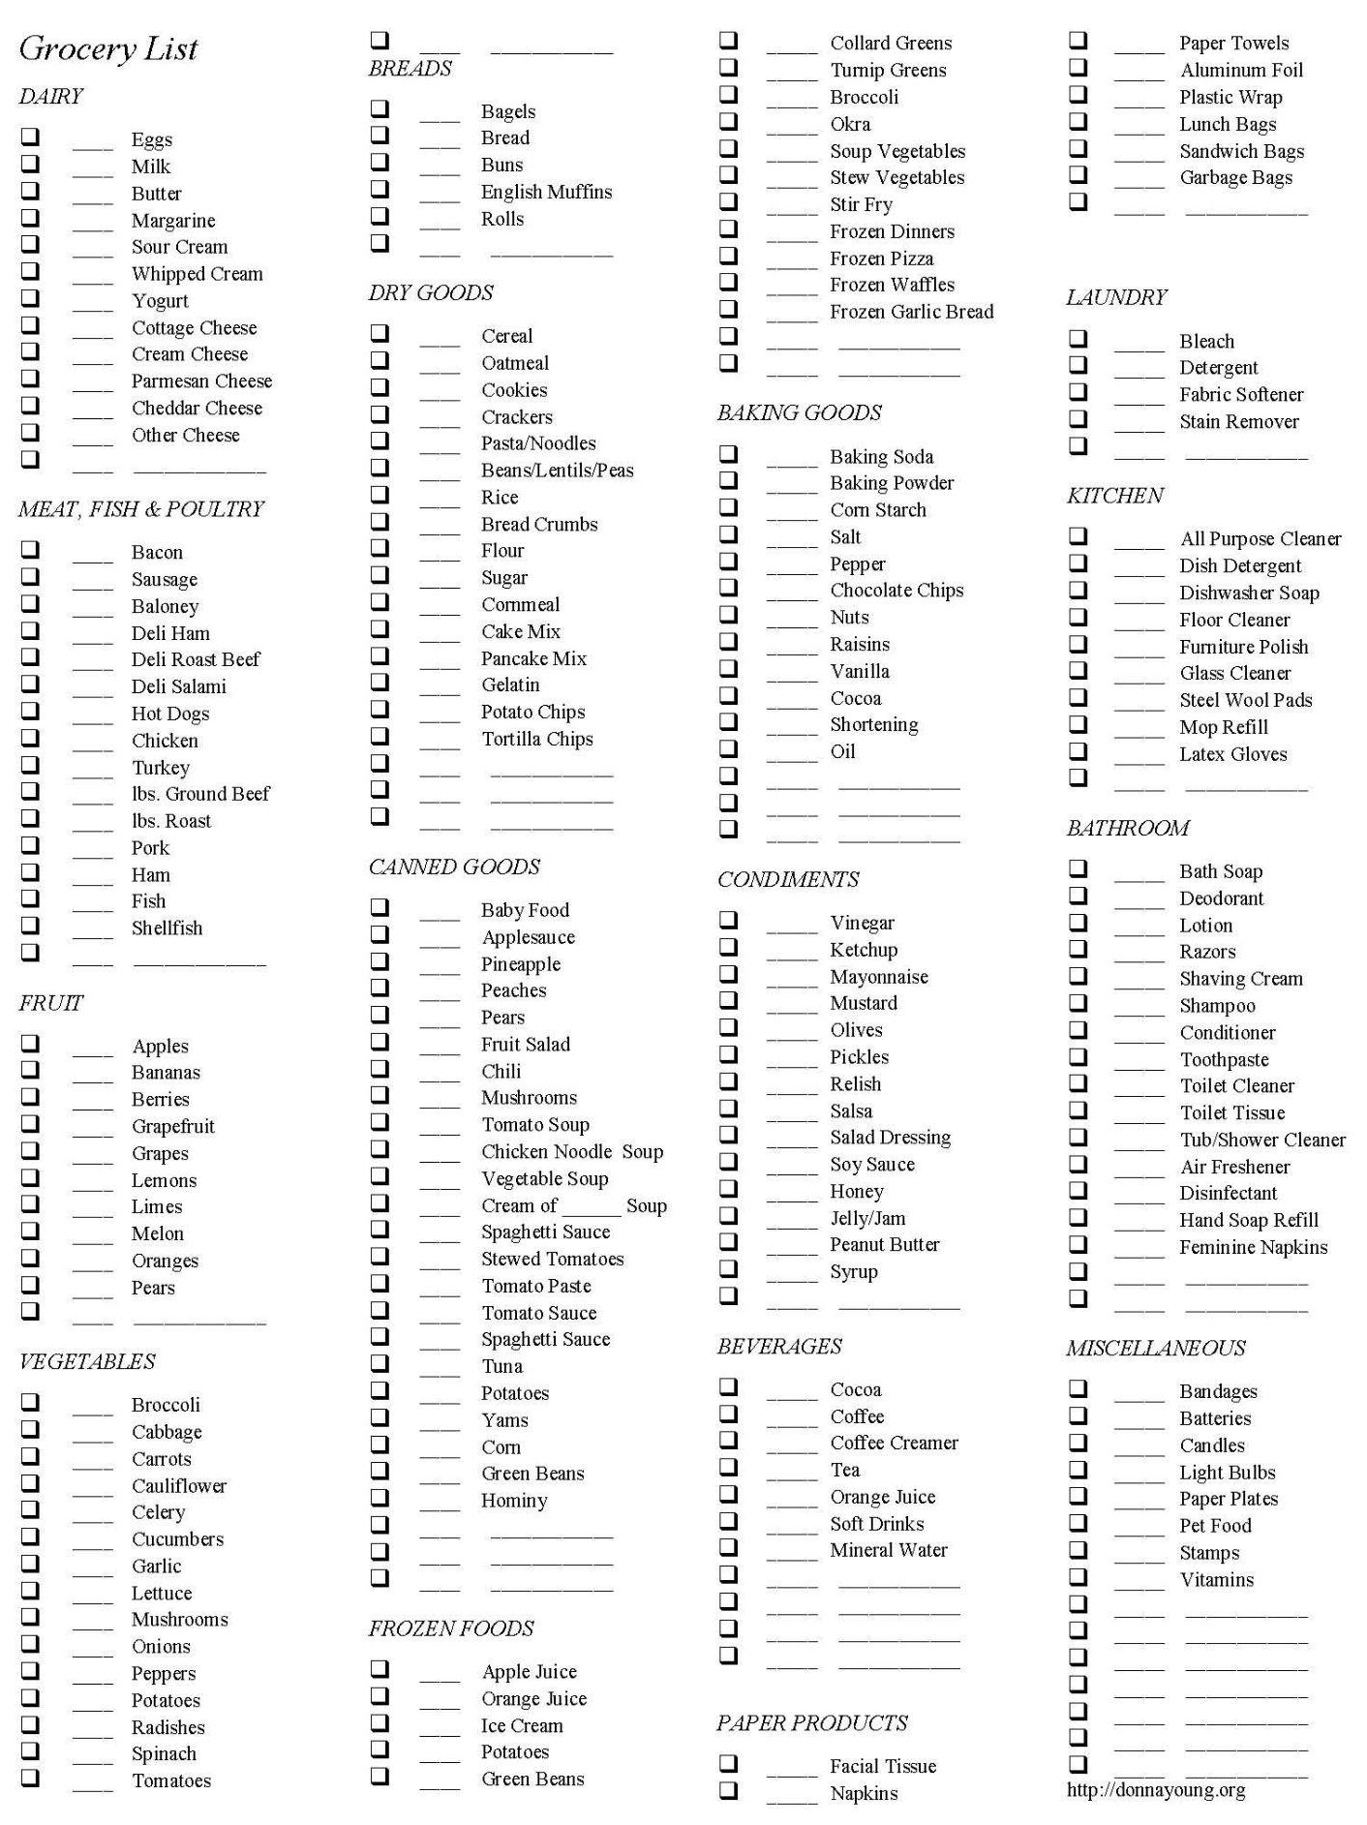

Inventory

What is it? | Model Number | Serial Number | Price Paid | Where Paid | Insured?
(Print more if needed)

Budget sheet
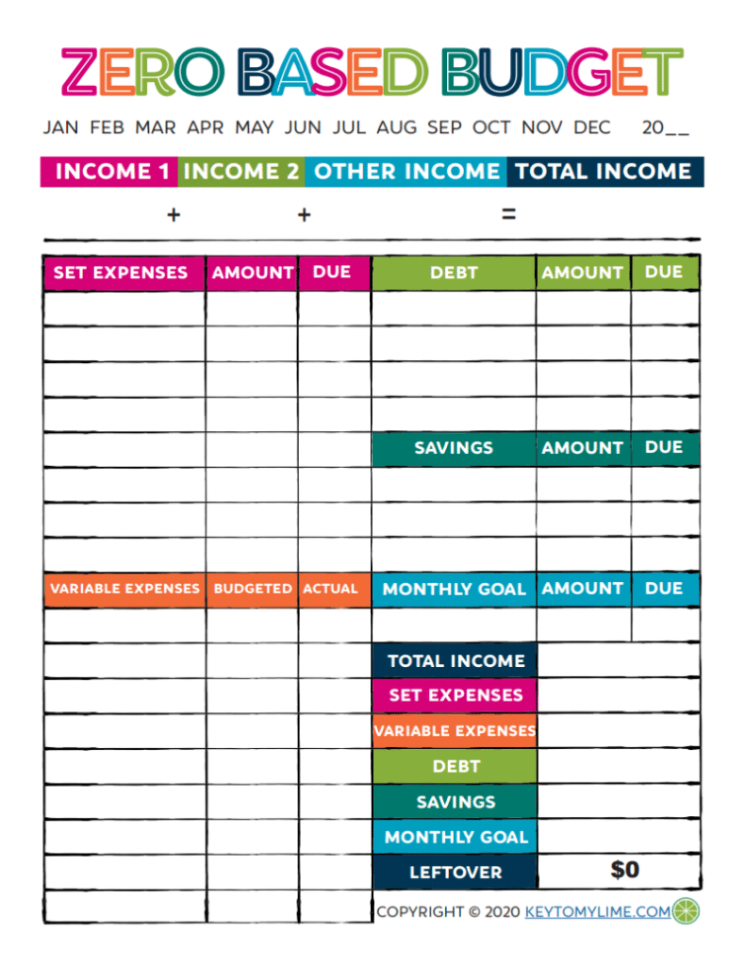

Household Maintenance

Monthly checklist
Air Quality and Vents
- Clean the furnace filter to remove dust build-ups, make it easier to regulate your home's temperature, and ultimately decrease energy bills.
- Vacuum heat registers and heat vents.
- Check that indoor and outdoor air vents are not blocked.
Plumbing and Water
- Check the water softener and replenish salt if necessary.
- Clean the garbage disposal by grinding ice cubes, then flushing with hot water & baking soda.
- Inspect tub and sink drains for debris; unclog if necessary.
- Flush out hot water from the water heater to remove accumulated sediment.
Home Safety
- Test smoke alarms, carbon monoxide detectors, & all ground-fault circuit interrupters. Check the gauge & expiration date on fire extinguishers.
- Inspect electrical cords for wear.

Fall checklist
Landscaping and Yard Prep
- Rake leaves and aerate the lawn. Remove leaves and debris from gutters & downspouts.
- Keep firewood away from the house, trim shrubs, & repair rotten or broken woodwork. Remove any wasp nests hanging from eaves or overhangs.
- Drain & winterize exterior plumbing, including hoses and in-ground sprinkler systems.
Home Exterior Repairs and Updates
- Mend cracks and gaps in the driveway and walkway.
- Touch up exterior siding and trim with paint.
- Power-wash windows and siding.
- Inspect roofing for missing, loose, or damaged shingles and leaks.
- Repair or replace siding. Clean window and door screens.
- Replace old, drafty windows for more energy-efficient models.
- Seal cracks & gaps in windows & doors with caulk or weather stripping; replace if necessary.
- Inspect exterior door hardware; fix squeaky handles and loose locks.
- Wrap insulation around outdoor faucets and pipes in unheated garages.
Interior Cleaning and Inspection
- Have the forced-air heating system inspected by a professional. Schedule an inspection in late summer or early fall before the heating season begins.
- Check the fireplace for damage/hazards & clean the fireplace flues. Have your fireplace professionally inspected.
- Tune up major home appliances before the holidays.
- Install a smoke detector on every floor of your home, including the basement or Replace the batteries in smoke & carbon monoxide detectors.
- Clean carpets & Vacuum lint from the dryer vent.
- Check the water heater for leaks.

Winter checklist
Exterior Repairs and Updates
- Cover your air-conditioning unit.
- Inspect the roof, gutters, and downspouts for damage after storms.
- Stock up on sidewalk salt and ice melt.
Interior Cleaning and Inspection
- Check the basement for leaks during thaws.
- Vacuum bathroom exhaust fan grill.
- Vacuum refrigerator and freezer coils and empty and clean drip trays.
- Clean drains in sinks, tubs, showers, and dishwashers.
- Set up mouse traps as needed.

Spring Checklist
Landscaping and Yard Prep
- Refinish the deck.
- Fertilize your lawn.
- Prune trees and shrubs.
Exterior Repairs and Updates
- Clean window and door screens.
- Remove leaves & debris from gutters and downspouts.
- Have a professional inspect and pump the septic tank.
- Inspect roofing for missing, loose, or damaged shingles and leaks.
- Inspect the chimney for damage.
- Wash windows.
- Power-wash siding.
- Repair or replace caulking & weather stripping around windows, doors, & mechanicals.
- Remove the insulation from outdoor faucets and check sprinkler heads.
Interior Cleaning and Inspection
- Clean faucet aerators and showerheads to remove mineral deposits. Repeat in the fall.
- Change the air-conditioner filter.
- Polish wood furniture and dust light fixtures.
- Replace the batteries in smoke and carbon monoxide detectors.
- Inspect sink, shower, and bath caulking for deterioration.
- Vacuum lint from the dryer vent.
- Have the air-conditioning system serviced.
- Drain or flush the water heater.

Summer Checklist
Interior Cleaning and Inspection
- Remove lint from your dryer vent.
- Clean kitchen exhaust fan filter.
- Clean refrigerator and freezer coils and empty and clean drip trays.
- Check the dishwasher for leaks.
- Check around kitchen and bathroom cabinets and around toilets for leaks.
- Replace faucet and showerhead washers if needed.
- Seal tile grout.

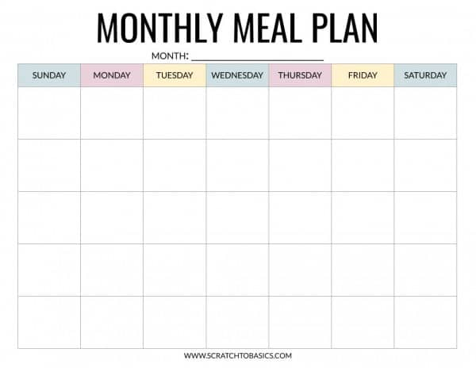
Print as many as you need (12)

